# Section: 16-1: Thirteenth, Fourteenth and Fifteenth Vassa

# (Age 47 to 49)

In the previous section (15-4), we explored the Buddha’s eleventh and twelfth *vassa* (rainy retreats), which he spent in Nāḷa (Ekanīla) in the ancient Magadha region and in the brahmin village of Verañjā, identified with present-day Atranji Khera in Uttar Pradesh. Now, we turn our attention to the locations where the Blessed One resided during his thirteenth, fourteenth, and fifteenth *vassa*, as well as the profound teachings he imparted during this period.

## Thirteenth Vassa – On the Serene Heights of Mount Cāliya (Age 47)

At this stage, the Blessed One was around forty-seven years old—an age often considered the peak of wisdom and experience. He had already spent more than a decade tirelessly teaching, traveling, and establishing the Dhamma for the welfare of both monks and lay followers. According to various sources, the Buddha chose the peaceful heights of Mount Cāliya (*Cāliya Pabbata*) as his retreat for the thirteenth rainy season.

### Scriptural References to the Buddha’s Stay at Cāliya

The scriptures provide clear evidence of the Buddha’s presence on Mount Cāliya:

**From the Udāna (Ud 4.1)**:

*“Thus have I heard: At one time, the Gracious One was dwelling near Cālikā, on the Cālikā mountain. Then, at that time, Venerable Meghiya was the Gracious One's attendant.”*

**From the Aṅguttara Nikāya (AN 9.3)**:

*“Thus have I heard: On one occasion, the Blessed One was dwelling at Cālikā, on Mount Cālikā. Now on that occasion, the Venerable Meghiya was the Blessed One’s attendant.”*

### Other sources

Additionally, verses from ancient sources beautifully describe the Buddha’s presence at this retreat:

1) The thirteenth on Mount Cāliya (*terasamaṁ Cāliyapabbate) [1]*

2) The Teacher of the Three Worlds, the Champion, whose face was like a blossoming lotus, who shone like the radiant sun, who embodied boundless compassion and lived for the benefit of all beings—spent his thirteenth Rains Retreat on the magnificent Mount Cāliya*.[2]*

(*Phulla-aravinda-vadano ravi-cāru-sobho dayā-adhivāso, Ti-Loka-Garu Vīro lokassa attha-cariyāya, terasamamhi Vasse, rucira-Cāliya-pabbatasmiṁ vāsaṁ akā.*)

3) Moreover, some sources indicate that after spending time at the Jetavana monastery in Sāvatthi following the twelfth *vassa*, the Buddha journeyed to the region of Cālika, where he eventually settled on the tranquil slopes of Cāliya Pabbata for his retreat. [3]

## Where was Cāliya mountain (*Cālika-pabbata)* placed in Ancient India?

**1**. The ancient location Cālikā, situated on Cālikā Mountain, is believed to be associated with Chalika Hill in present-day India. While its exact location is uncertain, some scholars suggest it could be in the eastern region of India, possibly near modern-day Bihar or Jharkhand, where many Buddhist sites are located. One possible identification is Chalika Parvat (Chalika Hill), which may correspond to a smaller hill or mountain in regions historically connected with the Buddha’s travels. [4]

**2.** Renowned Buddhist Scholar Bhikkhu Ānandajoti, who has extensively researched the Buddha’s rains retreats, acknowledges the challenge of identifying certain locations. He states:

***“Some of the places we cannot identify. These include the 13th, 18th, and 19th vassas on Mount Cāliya****.” [5]*

**3.** A possible clue comes from the Aṅguttara Nikāya (AN 9:3), which places Cāliya village near the Kimikālā River and the town of Jantugāma:

*“ Then, in the morning, Venerable Meghiya dressed, took his bowl and robe, and entered* ***Jantugāma*** *for alms. When he had walked for alms in Jantugāma, after his meal, on returning from his alms round, he went to the bank of the* ***Kimikālā River****. As he was walking and wandering around for exercise along the bank of the Kimikālā River, Venerable Meghiya saw a lovely and delightful mango grove.”*

**The Uncertain Geography of Jantugāma and the Kimikālā River:**

Despite references in the scriptures, the precise locations of Jantugāma and the Kimikālā River remain unknown. However, historical and textual analysis allows us to make some educated guesses:

* **Jantugāma** – The name suggests it was a significant village (*gāma*) during the Buddha’s time, yet it does not frequently appear in major Buddhist texts or inscriptions. Some scholars speculate that it was situated in **Magadha or Kosala**, but no confirmed identification exists.
* **Kimikālā River** – This river is rarely mentioned in Buddhist literature, and its exact location has been lost to history. Some scholars hypothesize that it may have been a tributary of the Ganges, but no conclusive archaeological or textual evidence supports this theory. Some scholars suggest that the Kimikala River was a muddy-water river, possibly originating from these marshlands. The river is believed to have been called Kimikala because it was abundant in black worms (*kālakimīnam bahulatāya*). [6]

**4. Ancient Commentarial Accounts**

According to Buddhist commentaries, Cālikā was both the name of a city and a nearby mountain where the Buddha resided. A large monastery was built at the site, where the Buddha was sustained by the generosity of the local people. [7]

**5.** **Other Historical References to Cālikā also called Jālikā**

1) **Cālika/Jālikā** – A village near Cālika-Pabbata, where the Buddha spent his 13th, 18th, and 19th vassa after attaining Enlightenment. Close to Cālika was Jantugāma, the town where Venerable Meghiya collected alms. Nearby was the Kimikālā River, along whose banks lay a mango grove. (*Aṅguttara Nikāya 4.354; Udāna 4.1; Dhammapada Commentary 1.287*) [8]

6) **The Origin of the Name Cālika** – Ancient sources describe a bog (cala-paṅka) surrounding the city, giving it the appearance of being unstable or “moving,” which is thought to be the origin of its name Cālika (meaning ‘shaky’ or ‘unstable’). The White Hill – A prominent white-coloured hill stood near the town. On dark *uposatha* (observance) days, it appeared to shift in the moonlight, reinforcing its association with movement (*cala*). This feature may explain why both the town and the mountain were called Cālika. [9]

7 ) Atop this sacred hill, a large monastery was built through the support of generous donors. It was here that the Buddha spent his thirteenth vassa, in peaceful seclusion, imparting wisdom to those who sought his guidance. [10]

### Possible Location of the Ancient Chalika Hills

Based on the above information, it can be concluded that the village or town of Chalika was situated **near a vast marshy area of Ganges River Basin.** Could the Ancient Chalika Hills be in Bihar-Jharkhand?

According to the above facts, it is possible that the ancient Chalika Hills was located in the Bihar-Jharkhand region. Geographically, this area is characterized by hilly terrain, lush forests, and diverse wildlife, including elephants and tigers. The region experiences heavy monsoon rainfall, which likely results in boggy and marshy landscapes.

Ancient sources describe a bog (cala-paṅka) surrounding the city, giving it an appearance of instability or movement. This is believed to be the origin of its name, Cālika, which means "shaky" or "unstable." Additionally, historical accounts mention a prominent white-colored hill near the town/village. On dark uposatha (observance) days, it appeared to shift in the moonlight, further reinforcing the association with movement **(**cala)**.** This unique feature may explain why both the town and the mountain were called Cālika.[11]

Furthermore, Jharkhand, located in eastern India, is renowned for its geographical diversity. It is bordered by Bihar to the north, Uttar Pradesh and Chhattisgarh to the west, Odisha to the south, and West Bengal to the east, serving as a crucial link between northern and southern India. Spanning approximately 79,714 square kilometres, Jharkhand's landscape includes rolling hills, mineral-rich plateaus, and dense forests. The state's name, **"**Jharkhand", meaning ***"land of forests,****"* reflects its extensive woodland cover, which accounts for about 29% of its total area. Several rivers flow through the state, supporting agriculture and sustaining the local population.[12]

Given these geographical features—hilly landscapes, dense forests, monsoon-fed wetlands, and historical descriptions of an unstable or shifting terrain—Jharkhand presents a compelling case as a potential location for the ancient Chalika Hills.

The exact location of Chalika Hills, where the Buddha spent three vassas (rainy seasons), remains uncertain due to limited historical references. However, the **Gautam Buddha Wildlife Sanctuary** in the Bihar-Jharkhand region presents a compelling site for exploration, as its geographical features closely resemble those described in historical accounts.

#### The possibilities:

**1. Gautam Buddha Wildlife Sanctuary and Chalika Hills**

* **Location:** **The Gautam Buddha Wildlife Sanctuary** is located in **Gaya (Bihar) and Koderma (Jharkhand)** districts. (see the maps below)
* **Historical Significance:** While this region is named after the Buddha, the exact reason for this naming is unclear. It could be due to historical connections, traditional beliefs, or even later naming conventions.
* **Geography:** The sanctuary consists of **low hills and forests**, which could match descriptions of a retreat-like place for monastic practice.

**2. Chalika Hills in Buddhist Texts**

* The **Commentaries (Atthakatha)** mention that the Buddha spent three vassas in **Chalika Hills**. However, ancient sources do not precisely locate it.
* Some scholars have suggested Chalika Hills locations in **Bihar/Jharkhand** due to the Buddha’s frequent travels in Magadha and Anga regions.

**3. Possible Correlation**

* The **Gautam Buddha WLs area is within the Magadha region**, which was central to the Buddha’s wanderings.
* If local traditions support a connection, there may be some basis for identifying **Chalika Hills with this region**.
* However, without archaeological evidence or early references explicitly linking the two, it remains a hypothesis.[13]

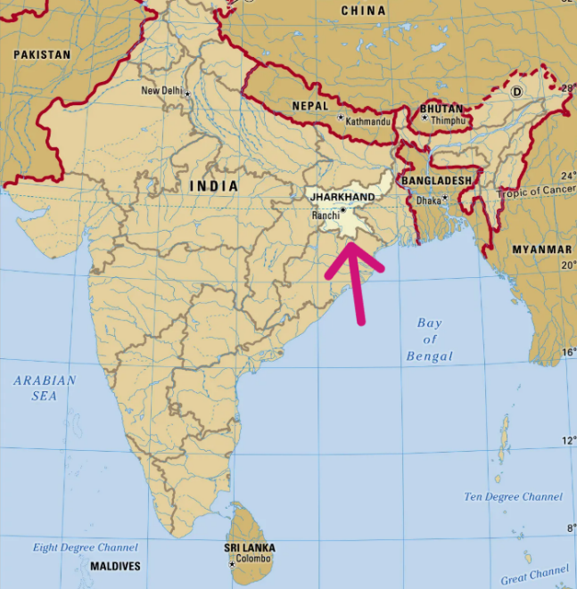

**Modern map showing the location of the Jharkhand Region** [14]

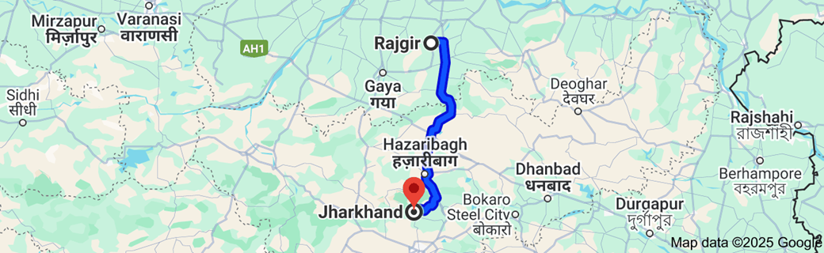

**Map showing the location of Jharkhand: Distance from Rajgir to Jharkhand is 217.7 km**

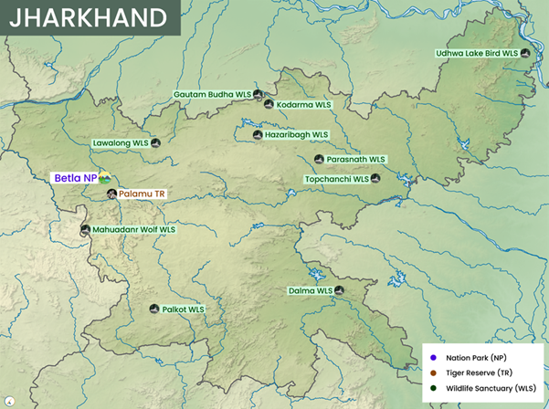

**Location map of Gautam Buddha WLs area in** **Jharkhand [15]**

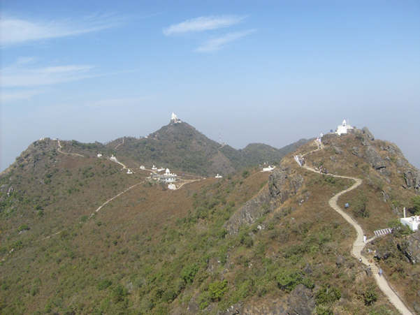

**Modern day picture of hills in Jharkhand [16]**

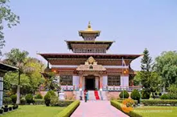

**Gateway to Gotama Buddha WL sanctuary in Jharkhand [17]**

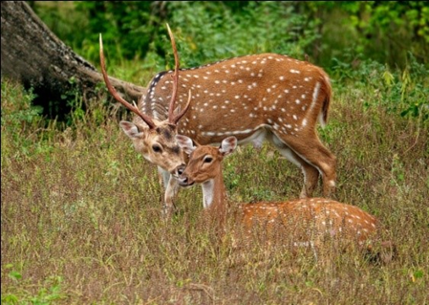

**Wild life in Gautam Buddha WL Sanctuary [18]**

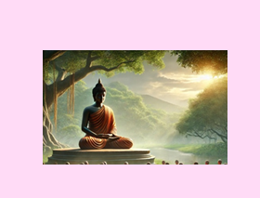

**Buddha meditating on Cālika Hill** **[19]**

## Dhamma Teachings Delivered During This Period

According to the scriptures, during this time, the Blessed One was accompanied by Venerable Meghiya as his personal attendant. While the Buddha was often surrounded by a large retinue of monks, journeying from place to place for the benefit of the lay community and to provide his disciples with opportunities for solitude, there were moments when he chose seclusion himself. Perhaps, as one who always emphasized solitude as essential for spiritual growth, the Buddha wished to spend his thirteenth rainy season away from the hustle and bustle of cities and towns, finding refuge in the serene beauty of this remote natural setting.

The fact that he later spent two more rainy seasons—the 18th and 19th—at the very same Chalika Hills further supports this idea. Could it be that the All-Compassionate One, perceiving that his devoted attendant, Venerable Meghiya, was ready for a profound transformation, chose this retreat to grant him the opportunity to deepen his practice and attain noble realizations?

Thus, the Buddha’s retreat on Mount Cāliya was not only a time of seclusion but also a period of deep teaching—guiding disciples in the cultivation of insight, patience, and wisdom.

### Advice to Venerable Meghiya

While the exact teachings given during this *vassa* are not fully detailed in the texts, the presence of Venerable Meghiya as the Buddha’s attendant suggests that this period included significant instructions on mental cultivation and solitude. The Meghiya Sutta (Ud 4.1) highlights a crucial lesson:

One day, while collecting alms in the village of Jantu, Venerable Meghiya came upon a mango grove near the Kimikala River. Struck by its serene atmosphere, he felt it would be an ideal place for meditation. Eager to cultivate his practice, he approached the Blessed One and requested permission to go there. [20]

The Buddha gently advised him:  
*"Meghiya, since we are alone, wait until another bhikkhu arrives."*

However, Venerable Meghiya respectfully insisted:  
*"Bhante, for the Blessed One, there is nothing more to be done, nor anything left to perfect. But for me, there is still work to be done and progress to be made."*

After making his request three times, the Buddha finally said:  
**"***Since you are so determined to strive, Meghiya, what can I say? You may go at your own convenience."*

With great enthusiasm, Venerable Meghiya set off for the mango grove. However, as he sat in meditation, his mind became restless, struggling to remain focused. Instead of attaining deep Samādhi, he was overwhelmed by a flood of unwholesome thoughts—sensual desire, aversion, and cruelty. [21]

Disheartened, he returned to the Buddha and humbly shared his experience. With boundless compassion, the Blessed One expounded the essential qualities that support meditation, guiding him toward the path of true liberation. The Buddha gently reminded him that true spiritual growth requires **mature wisdom, the right conditions, and the support of good companions** (*kalyāṇamitta*). This teaching reinforces an essential principle in the Dhamma:

Wisdom does not arise merely through solitude, but through the careful development of virtue, reflection, and the guidance of the wise.

#### Essential Factors That Support Meditation

The Blessed One, in his boundless compassion, illuminated the path for the devoted disciple Meghiya, revealing the essential factors that lead to the ripening of liberation. He declared:

*"Meghiya, when the liberation of the mind has not yet matured, there are five factors that lead to its fulfillment. What are these five?"*

1. Kalyāṇamittatā – The Blessing of Noble Friendship  
   A bhikkhu flourishes in the company of wise and virtuous Dhamma friends, whose presence nurtures his resolve and strengthens his practice.
2. Sīla – The Foundation of Virtue  
   He abides in purity, upholding the Pātimokkha discipline with unwavering commitment, guarding his conduct with mindfulness and restraint.
3. Dhamma-savana – The Nourishment of the Mind  
   He listens to and reflects upon the sublime teachings—discourses that inspire renunciation, contentment, solitude, detachment, diligence, virtue, concentration, wisdom, liberation, and the direct realization of truth.
4. Viriya – The Unyielding Effort  
   With resolute energy, he diligently abandons unwholesome qualities and cultivates wholesome states, steadfast in his duty to perfect virtue and wisdom.
5. Paññā – The Penetrating Wisdom  
   He discerns with clarity the arising and passing of all phenomena, possessing wisdom that is noble, profound, and leads to the complete cessation of suffering.

#### The Further Four Factors

Having firmly established himself in these five qualities, the earnest bhikkhu further cultivates four essential meditative perceptions:

1. The Perception of Unattractiveness (Asubha-saññā) – To transcend the grip of lust, he contemplates the true nature of the body, perceiving its impermanent and conditioned nature.
2. Loving-Kindness (Mettā-bhāvanā) – To dissolve the flames of ill-will, he radiates boundless loving-kindness, embracing all beings with compassion and goodwill.
3. Mindfulness of Breathing (Ānāpānasati) – To quell the restless wanderings of the mind, he anchors himself in the breath, cultivating deep tranquility and unwavering focus.
4. The Perception of Impermanence (Anicca-saññā) – To uproot the conceit of ‘I am,’ he contemplates the transient nature of all things. With the stabilization of this perception, the realization of non-self (anattā) deepens, culminating in the direct experience of Nibbāna—the ultimate freedom, here and now. [22]

#### The Awakened Realization

Shortly after imparting this sublime discourse to Venerable Meghiya, the Buddha uttered the following exalted verses (Udāna): [23]

*"There are low thoughts, fine thoughts,*  
*Together with elation in the mind,*  
*Not having understood these thoughts of the mind,*  
*The unsteady mind runs here and there.*

*Having understood these thoughts of the mind,*  
*He who is ardent, mindful, restrains them.*  
*Also elations that have not arisen in the mind—*  
*An Awakened One has given these up completely."*

#### The Triumph of Venerable Meghiya

In due course, Venerable Meghiya, recognizing the weight of his initial heedlessness, surrendered himself completely to the Blessed One’s guidance. As an obedient disciple, he cultivated the path with unwavering faith and diligence. His perseverance bore fruit, and he ultimately attained the highest goal—Arahantship. His own words in the Theragāthā resound with the victory of final liberation:

*"He counselled me, the great hero,*  
*The one who has gone beyond all things.*  
*Upon hearing his teaching,*  
*I remained close to him, ever mindful.*  
*I have attained the threefold knowledge*  
*And perfectly fulfilled the Buddha’s instructions."* [24]

Thus, the journey of Meghiya stands as a beacon for all who seek the path—an unwavering testament that, with the right conditions and steadfast effort, the heart’s liberation is within reach.

With that inspiring event we will conclude the thirteenth vassa.

# Fourteenth Vassa at age 48

Tradition says that the Buddha completing the thirteenth rainy season at Cālika Hills set out from there, eventually arrived at Jetavana monastery at Sāvatthī He spends the fourteenth vassa there amidst of large Sangha community and lay followers in the famous Jetavana Monastery.

#### The following sources also confirm this:

1) The fourteenth in the Jeta’s Wood great Monastery (near Sāvatthī)

*( cuddasamaṁ Jetavanamahāvihāre ). [25]*

2) The Master of the Dhamma, whose delightful hands and feet were like Bandhuka flowers, devoted to the welfare of all beings — the Hero, the Sage of Great Power — in the fourteenth Rains Retreat, dwelt in the very delightful and excellent Jeta’s Wood. (*Bandhuka-puppha-sama-pāda-kara-abhirāmo Dhamma-Issaro sakala-satta-hitesu yutto — Dhīro Mahiddhi Muni — cuddasamamhi Vasse, suramme pavara-Jetavane vāsaṁ akā). [26]*

3) After observing the thirteenth at the monastery on Cālika Hills, the Buddha arrived in Sāvtthi and stayed at the Jetavana monastery to observe the fourteenth vassa. [27]

## Where was Sāvatthī during the time of the Buddha?

Sāvatthī, one of the most significant cities during the time of the Buddha, holds an essential place in the history of Buddhism. It was the capital town of Kosala in India and one of the six great Indian cities during the lifetime of the Buddha. It was in this thriving city that the Buddha spent a considerable amount of time, teaching, guiding, and establishing the early community of monks and lay followers. Sāvatthī, with its serene surroundings and spiritual energy, became a vibrant centre for the Dhamma.

The city is particularly famous for the Jetavana Monastery, gifted to the Buddha by the wealthy merchant Anāthapiṇḍika. This monastery became the Buddha's primary residence for many years and a place where many key teachings were delivered, including some of the most profound discourses. It is where the Buddha taught his followers the deeper truths of life, such as the Four Noble Truths, the Eightfold Path, and countless other principles that have shaped Buddhist practice ever since.

Sāvatthī's importance lies not only in its physical presence but in its role as the heart of spiritual transformation. It was a place of refuge, where beings from all walks of life could seek solace, wisdom, and a path to liberation. For Buddhists, it is a symbol of spiritual growth and the potential for enlightenment that can arise in a supportive community.

Today, the legacy of Sāvatthī endures, reminding us that just as the Buddha found a place to spread his wisdom, we too can cultivate spaces in our lives where the teachings of the Dhamma can flourish, transforming our minds and hearts toward peace, compassion, and understanding. Sāvatthī represents the flourishing of wisdom, where each step towards liberation is taken with intention, kindness, and the pursuit of true insight into the nature of suffering and its cessation.

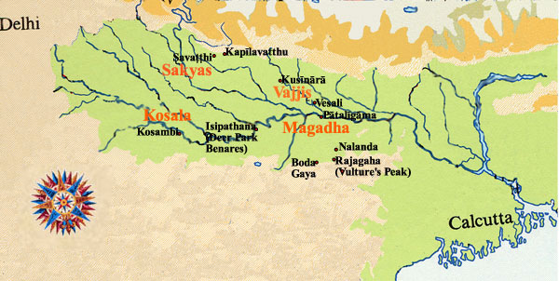

**Location of Sāvatthī in Ancient India [28]**

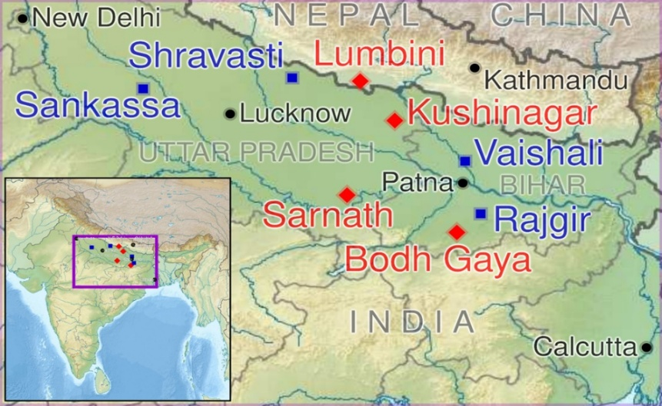

**Location of Sāvatthī in Modern India [29]**

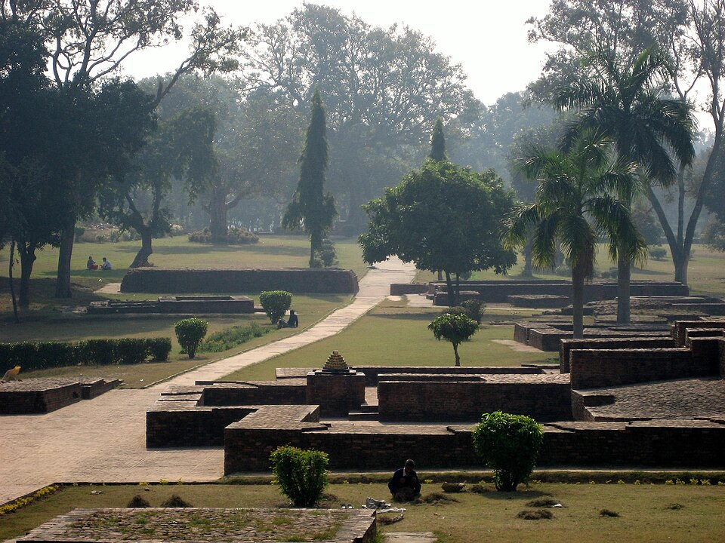

**Ruins of Sāvtth**i [30]

## Profound Dhamma Teachings of this Period

### The Buddha’s Timeless Advice to Venerable Rāhula

According to tradition, this illuminating discourse was delivered to Venerable Rāhula when he was around eighteen years old, guiding him away from the entanglements of worldly desire and towards the path of true renunciation. [31]

On one occasion as Rāhula followed the Blessed One on his alms round, his heart swelled with admiration for the Buddha’s radiant presence. Seeing the perfect form of his father, he reflected,

**“I too am handsome like the Buddha. His form is beautiful, and so is mine.”**

Perceiving his son’s thoughts with boundless wisdom and compassion, the Buddha knew that unchecked vanity could become a subtle but perilous snare. Wishing to free Rāhula from the illusion of self and attachment to the body, he spoke a profound teaching—guiding him to see beyond fleeting appearances and to realize that the body is neither a self nor a possession of self. Thus, with gentle yet piercing words, the Buddha illuminated the path of wisdom, leading Rāhula towards deeper insight and liberation.

**The Essence of the Buddha’s Profound Counsel:[32]**

The Blessed One imparted a timeless truth to Venerable Rāhula, urging him to see with the eye of wisdom:

*“All forms—whether past, future, or present; internal or external; gross or subtle; inferior or superior; far or near—must be understood as they truly are: ‘This is not mine, this I am not, this is not myself.’”*

Hearing this piercing wisdom, Venerable Rāhula was deeply moved. He thought to himself, *“How could I go into the town for alms today, having been personally admonished by the Blessed One?”*

With a heart stirred towards deeper reflection, he turned back, seeking solitude beneath a tree. There, in quiet contemplation, he immersed himself in the Buddha’s words, allowing the light of insight to dispel the shadows of delusion.

Meditation on the Elements **[33]**

As evening fell, Venerable Rāhula approached the Buddha once more. To free him from attachment to the body, the Blessed One offered a profound teaching on the egoless nature of material form.

An ordinary person, untrained in the Dhamma, clings to the body as **“mine”** and mistakenly perceives it as a self. But the Buddha revealed that what we call the body is, in truth, nothing more than a composition of the four great elements—earth, water, fire, and wind.

He explained these elements in terms of their physical characteristics and functions:

* **Earth element (paṭhavi-dhātu):** The foundation and structural support.
* **Water element (āpo-dhātu):** The cohesive force that binds matter together.
* **Fire element (tejo-dhātu):** The transformative force responsible for maturation and temperature.
* **Wind element (vāyo-dhātu):** The movement and expansion within all physical forms.

The **earth element**, for instance, exists both internally and externally. Internally, it manifests as the solid components of the body—head hair, body hair, nails, teeth, skin, and all thirty-one bodily parts. Externally, it appears in the world around us, in the earth and all solid structures. In essence, there is no difference between the two; both are simply matter, devoid of self.

**Water Element (Āpo-dhātu)**

The water element exists in two forms: internal and external.

* **Internal water element** refers to the fluids within the body, such as blood, tears, urine, and other bodily liquids.
* **External water element** includes all sources of water outside the body, such as rain, rivers, lakes, and oceans.

Despite their distinction, both are simply manifestations of the water element, without any inherent self.

**Fire Element (Tejo-dhātu)**

The fire element also has internal and external aspects.

* **Internal fire element** is the heat within the body, responsible for warmth, digestion, and the aging process.
* **External fire element** includes sources of heat and combustion outside the body, such as sunlight, flames, and other sources of warmth.

Though they appear different, both are expressions of the same fiery nature.

**Air Element (Vāyo-dhātu)**

The air element is present both internally and externally.

* **Internal air element** consists of movements of air within the body, such as inhalation, exhalation, upward-moving and downward-moving winds, and other bodily airs.
* **External air element** manifests as the wind, breezes, storms, and cyclones in the natural world.

Both forms are simply the movement of air, without true ownership or self.

**Space Element (Ākāsa-dhātu)**

Though not considered a primary element, the Buddha taught about the space element as a derivative form of materiality, existing both within and outside the body.

* **Internal space element** refers to the empty spaces within the body, such as the ear canals, nostrils, and other hollow cavities.
* **External space element** includes the vast sky, the gaps between objects, and all open spaces in the external world.

Both are merely manifestations of emptiness, neither belonging to nor defining any self.

#### Seeing Reality as It Truly Is

The essence of understanding the elements is to perceive their true nature—there is nothing within them that can rightfully be called "me," "mine," or "myself." They are simply natural processes, existing both within and beyond the body, without ownership or selfhood.

The Buddha declared:

*"These elements must be seen as they truly are, with proper wisdom: ‘This is not mine, this I am not, this is not myself.’*"

When one contemplates them in this way, wisdom arises, dispelling the illusion of self. One sees that the body is nothing more than a temporary collection of elements, bound together for a time, only to disperse again. Realizing this truth, the heart becomes disenchanted, and from disenchantment arises a deep sense of detachment. The mind, no longer bound by craving, grows serene and unshaken.

To strengthen this impartial understanding, the Buddha encouraged Venerable Rāhula to meditate on the four elements with equanimity. In addition, he taught him the sublime practices of the Four Brahmavihāras—loving-kindness, compassion, altruistic joy, and equanimity—as well as the profound meditation on mindfulness of breathing (Ānāpānasati).

Thus, the Blessed One imparted his teaching, and Venerable Rāhula, deeply inspired, rejoiced in his father’s words. With unwavering diligence, he put the Dhamma into practice, walking the path with ardour and sincerity.

In the sections that follow, we shall see how his perseverance led him to the ultimate realization—Arahantship, the complete liberation of the mind.

# Fifteenth Vassa at age 49

According to tradition the Buddha having spent his fourteenth vassa in Sāvtthi, delivering many discourses for the welfare of Sangha community as well as lay people walked towards his home town in Kapilavattu to spend the fifteenth rainy season there. He arrived in the city with a large number of Sangha and stayed at Nigrodhārāma forest monastery. In section 14.2 of this series, we described Buddha’s first visit to Kapilavattu after his enlightenment. On that occasion Prince Nigrodhā donated this monastery in the great wood of Sakyan republic to the Buddha and the Sangha.

According to various sources, the Blessed One spent his fifteenth rainy season in Kapilavattu of the Sakyan republic.

1) The fifteenth near the great city of Kapilavatthu (at the Nigrodhārāma, near his home town, amongst the Sākiyans (*pañcadasamaṁ Kapilavatthumahānagare) [34]*

2) The Lion King of Sages, having slain the forest of elephant-like passion in his responsive relatives, in the fifteenth Rains Retreat, dwelt in the delightful Jewel Cave in Nigrodha’s Monastery, on a broad mountain near Kapilavatthu*.( Muni-Sīha-Rājā, veneyya-bandhu-vana-rāga-gaje vihantvā, pañcadasame Vassamhi, Kapilavatthu-dharādhara-uru-Nigrodha-Ārāma-ramaṇīya-Maṇi-Guhāyaṁ vāsaṁ akā).[35]*

3) After staying in Sāvatthī for the fourteenth vassa, remained in that city, after the end of the vassa for as long as there were beings worthy of teaching. Thereafter, he set out to administer the medicinal Dhamma teachings to all beings, and eventually arrived in the city of Kapilavattu together with a host of monks, and observed the fifteenth vassa at Nigrodhārāma. [36]

At this time of his visit his father King Suddhodhana has passed away as an arahant, his foster mother became the first bhikkhuni to ordain under the Buddha, and his step brother and sister Nanda Gotama and Nandā Gotami as well as his former wife Princess Yasodhara, his son Rahula all became disciples of the Buddha. Therefore, the Buddha had not his immediate family to welcome him. But he had many other Sakyans as his lay followers. One of them was Mahānama Sakyan, the elder brother of Venerable Anuruddha. Below we can see Mahānama Sakyan taking the good opportunity to visit the Blessed One and getting many valuable Dhamma advice from him which support to develop his spiritual path.

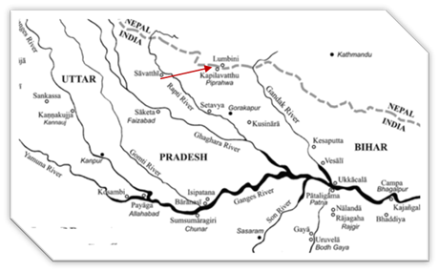

**The Walking tour of the Buddha after his 14th Vass- from Sāvatthī to Kapilavattu [37]**

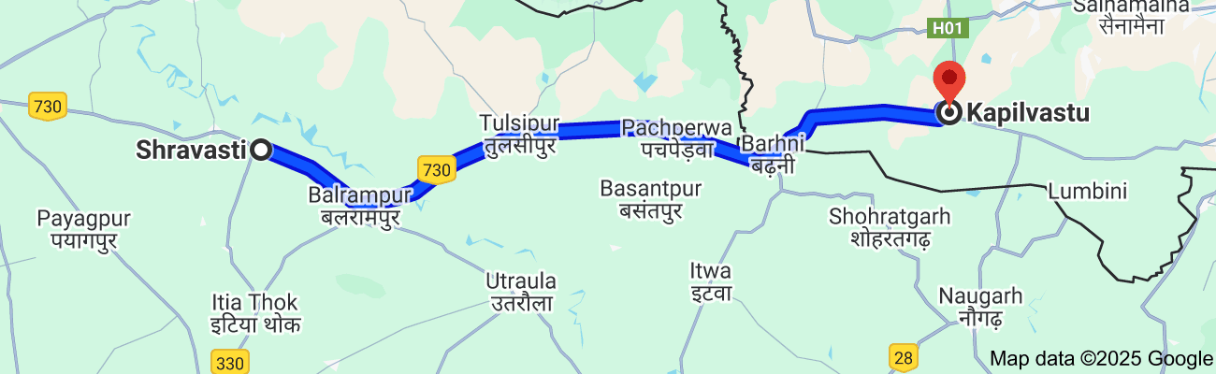

**Modern day map showing the distance from Sāvatthī to Kapilavattu, 112.9 km.**

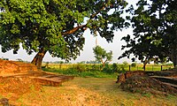

**The site of ancient Kapilavttu[38]**

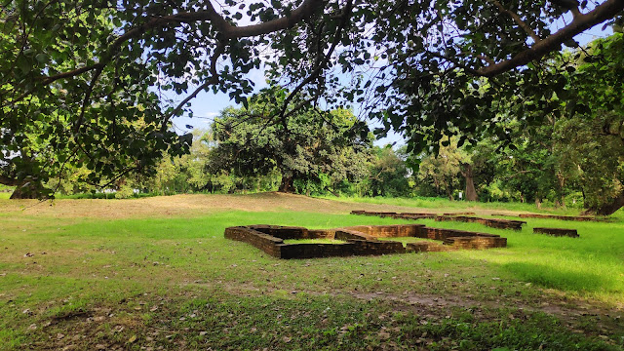

**Ancient remains of Kapilavastu palace complex. [39]**

## Significant Dhamma Teachings of this Period

### Advice to Mahānāma the Sakyan

According to the scriptures, while the Buddha was residing in Nigrodha’s Park at Kapilavattu, he delivered several profound discourses to Mahānāma the Sakyan. Although the suttas themselves do not explicitly mention that these teachings were given during the Buddha’s fifteenth vassa (rainy retreat), the Buddhist tradition affirms this, leading us to assume that the following discourses were delivered during that period.

#### The Destiny of One Who Lives According to the Dhamma **[40]**

On one occasion, Mahānāma approached the Blessed One with a deep concern weighing upon his heart. He said:

*"Bhante, when I enter Kapilavatthu in the evening, I sometimes encounter a stray elephant, a stray horse, a stray chariot, or a stray cart. At such moments, my mindfulness of the Buddha, the Dhamma, and the Sangha becomes unsettled. If I were to die at that very moment, what would be my fate? What would be my future rebirth?"*

Sensing Mahānāma’s apprehension, the Buddha, full of compassion and wisdom, reassured him:

*"Do not fear, Mahānāma! Your passing will not be an unfortunate one. When a person’s mind has been strengthened over a long time by faith, virtue, learning, generosity, and wisdom, even if his body is left to be consumed by crows, vultures, or other creatures, his mind—cultivated and purified by these noble qualities—will ascend to a higher destination, to distinction."*

To further illustrate this truth, the Blessed One offered two compelling similes:

**The Simile of the Ghee Pot**

*"Suppose a man were to submerge a pot filled with ghee in a deep pool of water and then break it. The fragments of the pot would sink downward, but the ghee or oil inside would naturally rise to the surface. Likewise, when a person’s mind has been fortified for a long time by faith, virtue, learning, generosity, and wisdom, it does not descend; rather, it rises towards a higher realm."* [41]

**The Simile of the Tree**

*"Consider a tree that leans and inclines towards the east. If it were cut at its root, it would naturally fall in the direction it was already leaning. In the same way, when a noble disciple possesses four essential qualities—confidence in the Buddha, the Dhamma, and the Sangha, along with perfect virtue—his inclination is towards Nibbāna. Even at the time of death, his mind will move in that direction."* [42]

With these insightful words, the Blessed One dispelled Mahānāma’s doubts, replacing his fear with clarity and joy. His compassionate teachings once again affirmed the unwavering truth: **one who diligently cultivates the Dhamma is never lost but is steadily carried towards liberation.**

### The Definition of a Lay Follower

In this discourse, the Buddha explained to Mahānāma the Sakyan who truly qualifies as a lay follower (upāsaka for a male lay disciple, upāsikā for a female lay disciple). A lay follower is not merely one who identifies with the Buddha’s teachings but one who embodies certain essential qualities. The Blessed One outlined five defining characteristics: **[43]**

1. Taking Refuge in the Triple Gem – A lay follower is one who has sincerely taken refuge in the Buddha, the Dhamma, and the Sangha, recognizing them as the supreme guides on the path to liberation.
2. Living by Virtue – One who is established in moral discipline by upholding the five precepts: abstaining from killing, stealing, sexual misconduct, false speech, and intoxicants that cloud the mind. This ethical foundation ensures purity of conduct and harmony in life.
3. Faith in the Buddha and His Teachings – A true lay disciple possesses unwavering confidence in the Buddha’s enlightenment and the truth of his teachings. This faith is not blind belief but an informed trust rooted in understanding and experience.
4. Generosity and a Joyful Heart in Giving – A lay follower is devoted to acts of charity, delighting in giving and sharing with others. This quality of generosity (dāna) fosters selflessness and accumulates great merit, leading to inner joy and spiritual progress.
5. Possession of Wisdom – True wisdom is not mere intellectual knowledge but deep insight into the nature of reality—seeing the arising and passing away of all phenomena. This wisdom is noble and penetrative, ultimately leading to the complete cessation of suffering.

Thus, a lay follower is not defined by mere affiliation but by the cultivation of these five qualities. Through faith, virtue, generosity, and wisdom, a lay disciple walks steadily on the path towards liberation, progressing in the Dhamma with a heart full of confidence and joy.

## Other Events Happened During this Period

Buddha’s encounter with Suppabuddha the Sakyan **[44]**

According to tradition while the Buddha was residing Nigrodhārāma nearby the city of Kapilvattu, Suppabuddha the Sākiyan who was the Buddha’s father-in-law obstructed the Buddha and the Sangha on their way to alms-round in the city.

It seems he was angry with the Buddha for two reasons: his daughter was Princess Yasodhara, and he was angry with the Buddha because as Prince Siddhartha went away from the palace leaving Princess Yasodhara for an ascetic life; the second reason was Venerable Devadatta was his son and he thought the Buddha has not treated him properly.

So, on one occasion when the Buddha was coming for almas in the city, he blocked the path and the Buddha his compassionate ways did not by pass him but turned away.

As the Buddha returned on his way, he smiled. Thereupon the Venerable Ānanda asked him: ***“****Venerable Sir, why do you smile?”*

The Buddha replied*:*

*“Ānanda, just look at Suppabuddha the Sākiyan.” –*

*“I see him, venerable Sir.”* –

*“He has committed a grievous wrong in refusing to make way for the Buddha. Seven days hence, on the ground floor of his palace, at the foot of the stairway, he will be swallowed up by the earth.”*

Hearing what the Buddha predicted from one of his servants, Suppabuddha Sakyan thought he could escape his fate, but he met it anyway; then the Buddha spoke a verse explaining the matter:

*“Neither in the sky, nor in the ocean,*

*nor after entering a mountain cleft:*

*there is no place found on this earth in which*

*death does not completely overcome one.”* Dhp:128

*Na antalikkhe, na samuddamajjhe”*   
(na pabbatānaṁ vivaraṁ pavissa- na vijjatī so jagatippadeso,  
yatthaṭṭhitaṁ nappasahetha maccu - yatthaṭṭhitaṁ nappasahetha maccu).



**An evil doer has no escape from his bad actions wherever he tries to hide*. [45]***

With that timely advice by the Blessed One we will close this section. The next section

16-2 describes how the Buddha spent his sixteenth and seventeenth rainy seasons.

### End Notes: Section 16-1

1. Source 1: Madhuratthavilāsinī (Buddhavaṁsatthakathā) of Bhadantâcariya Buddhadatta Mahathera: Translated by I. B. Honer, 1946.
2. Source 2: Jinacaritaṁ, The Life of the Victorious Buddha, translated by Bhikkhu Anandajoti.
3. Source 3: Chapter 32 : The Great Chronicles of the Buddhas by Venerable Mingun Sayadaw.
4. For more details See: Dictionary of Pāli Proper Names by G.P. Malalasekera. https://www.aimwell.org/DPPN/calika.html
5. See: “ Tathāgatassa Vassā- The Realised One’s Rains Retreats” by Bhikkhu Ānandajoti, https://ancient-buddhist-texts.net/Maps/During-Buddhas-Time/Map-08-Vassa.htm
6. According to the Udāna Commentary (UdA.217) * see also: https://www.palikanon.com/english/pali_names/ku/kimikaalaa.htm
7. See: AN: Notes: 1830.
8. Source: Dictionary of Pāli Proper Names by G.P. Malalasekera. https://www.aimwell.org/DPPN/calika.html
9. Chapter 32: The Great Chronicles of the Buddhas by Venerable Mingun Sayadaw.
10. See: AN: Notes: 1830.
11. Chapter 32: The Great Chronicles of the Buddhas by Venerable Mingun Sayadaw.
12. Source: <https://testbook.com/jharkhand-gk/geography-of-jharkhand>
13. Suggested Next Steps for Verification: 1) **Historical Maps & Records:** Checking colonial or medieval maps may reveal older names or references. 2) **Local Traditions & Archaeology:** Inquiring with historians or locals might provide oral traditions supporting the identification. 3) **Buddhist Textual Evidence:** Further analysis of Pali sources and commentaries might give additional hints.
14. Source: <https://www.britannica.com/place/Jharkhand>
15. Source: https://lotusarise.com/maps/states/jharkhand-map/
16. Source: https://en.wikipedia.org/wiki/Jharkhand
17. Source: http://www.nomadline.com/gautam-buddha-wildlife-sanctuary/
18. Source: https://forest.jharkhand.gov.in.onlinepanel.in.net/wings_wildlife_protectedarea_gautambudha.html
19. AI generated image.
20. AN9:3
21. Commentary says: “In five hundred successive lives he had been a king. There had been a stone slab there where he used to sit. He had come accompanied by three troops of dancing girls to amuse himself in the park. From the time Meghiya sat down there, it seemed as if he were no longer a monk but a king sitting on a regal couch beneath a white parasol, surrounded by his retinue of dancing girls. As he enjoyed his splendour, sensual thoughts arose in him. Just then, he seemed to see

    two thieves who had been arrested by his men and brought before him. In ordering one to be executed, thoughts of ill will arose in him; and in ordering the other to be imprisoned, thoughts of harming arose. Thus, he was enveloped by those unwholesome thoughts…”, see: AN: Note: 1833.
22. AN9:3
23. Ud:4.1. (Translated from the Pali by Bhikkhu Bodhi).
24. Thg:1.60 (Translated from the Pali by Bhante Sujato and Jessica Walton).
25. Source 1: Madhuratthavilāsinī (Buddhavaṁsatthakathā) of Bhadantâcariya Buddhadatta Mahathera: Translated by I. B. Honer, 1946.
26. Source 2: Jinacaritaṁ, The Life of the Victorious Buddha, translated by Bhikkhu Anandajoti.
27. Source 3: Chapter 32 : The Great Chronicles of the Buddhas by Venerable Mingun Sayadaw.
28. Source: <https://obo.genaud.net/backmatter/appendixes/buddhas_india/buddhas_india.htm>
29. Source: <https://en.wikipedia.org/wiki/Shravasti>
30. Source: https://en.wikipedia.org/wiki/Shravasti
31. See: MN: Note: 640. * During this period the Buddha was about 48 years old; calculating that the Buddha went forth at the age 29, the day prince Rāhula was born, this seems to be the right age of Venerable Rāhula.
32. MN:62 (Mahārāhulovāda Sutta).
33. MN:62
34. Source 1: Madhuratthavilāsinī (Buddhavaṁsatthakathā) of Bhadantâcariya Buddhadatta Mahathera: Translated by I. B. Honer, 1946.
35. Source 2: Jinacaritaṁ, The Life of the Victorious Buddha, translated by Bhikkhu Anandajoti.
36. Source 3: Chapter 33: The Great Chronicles of the Buddhas by Venerable Mingun Sayadaw.
37. Source: map based on Foot Prints in the Dust by Bhante S. Dhammika
38. Source: https://en.wikipedia.org/wiki/Kapilavastu
39. Giving no hint of its importance in the world or of its famous inhabitants says Deepak Anand in his blog.Source: **Deepak Anand** <https://www.blogger.com/profile/14702525494865105362>

    <https://nalanda-insatiableinoffering.blogspot.com/2022/01/kapilavastu-palace-city-witness-to-two.html>
40. SN55:21 & 22 (Mahānāma two suttas).
41. Ibid.
42. Ibid.
43. SN55: 37.
44. Source: Dhammapada Aţţakathā, translated by E.W. Burlingham & Bhikkhu Ãnandajoti.

    <https://ancient-buddhist-texts.net/English-Texts/Dhamma-Verses-Comm/09-12.htm> * This story also elaborated in Chapter 33: The Great Chronicles of the Buddhas by Venerable Mingun Sayadaw. * Suppabuddha, a wealthy Sakyan from Devadaha, was the father-in-law to the Buddha, as his daughter Yasodharā married Prince Siddhartha He was also the uncle of the Buddha as his wife Amita Devi was King Suddhona’s sister; his son was Devadatta.
45. Source: https://www.wisdomlib.org/buddhism/book/dhammapada-illustrated/d/doc1084354.html